**Setting Up Your Developer Environment**

**Windows 11**

Click on download now

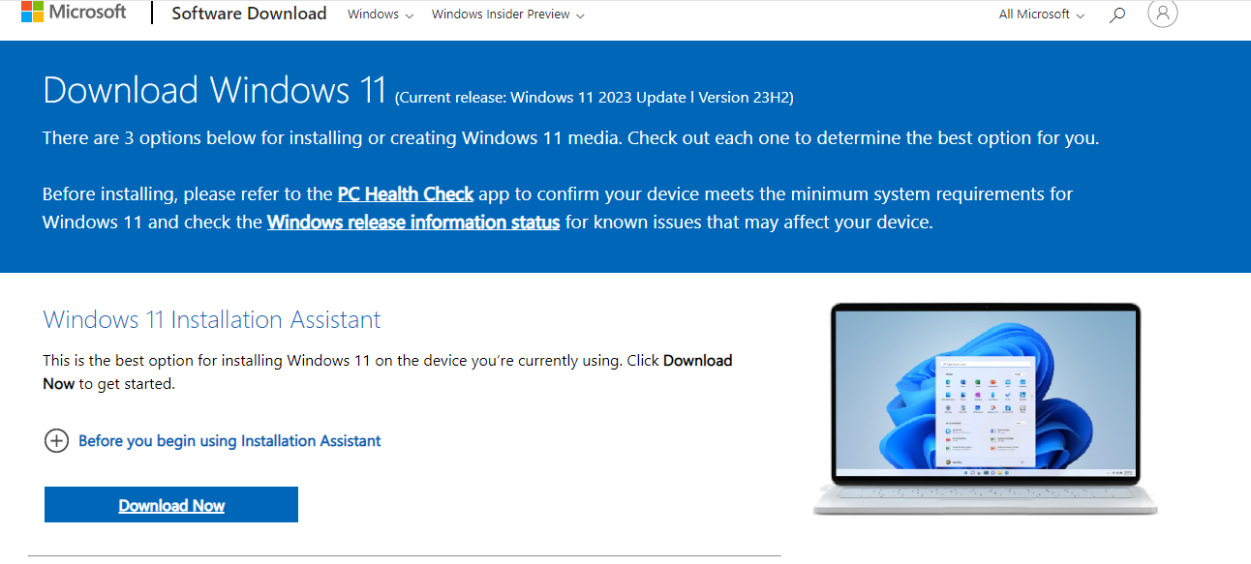

Save installer

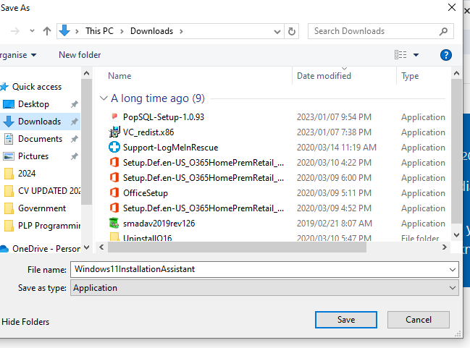

Click on yes to app to make changes to device

I downloaded PC health check app and received following message:

**Visual Studio Code Install**

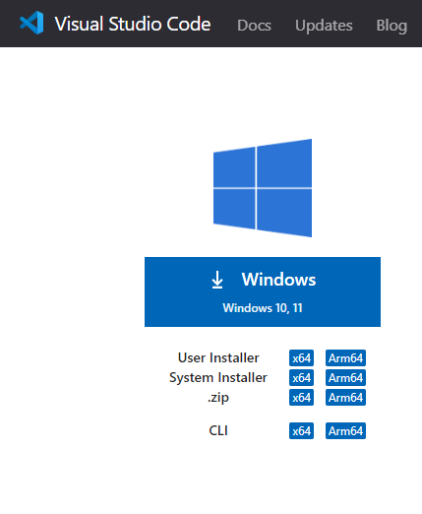

Save downloader

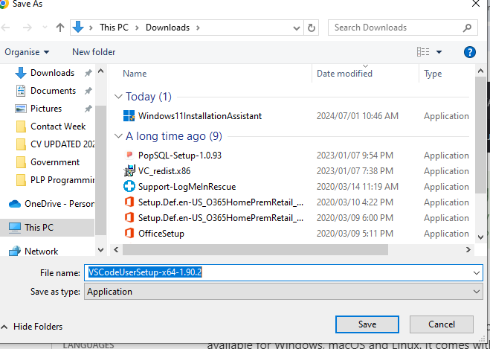

Accept agreement and click next

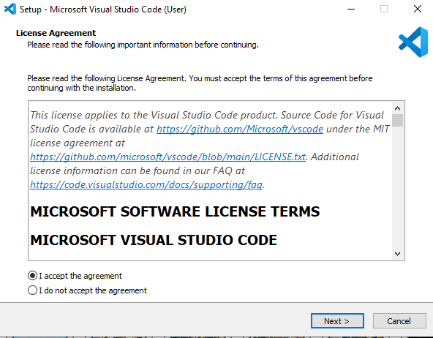

Click Next

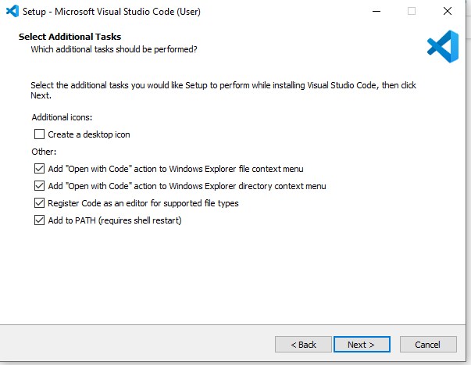

Click Install

**Git Install**

Open website

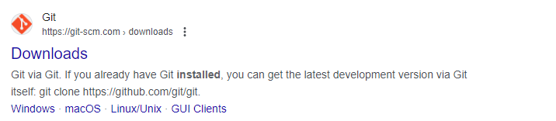

Click on Download for Windows and save installer

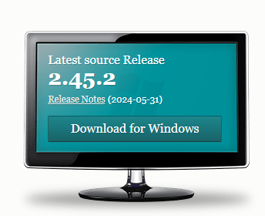

Open installer and click next

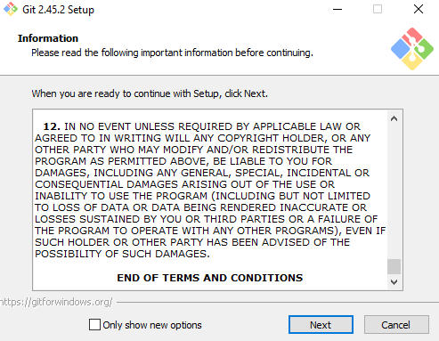

Click next

Click next

Click next

Click next

Click next

Click next

Click next

Click next

Click next

Click next

Click next

Click install

**Python Install**

Click on Python 3.12.4

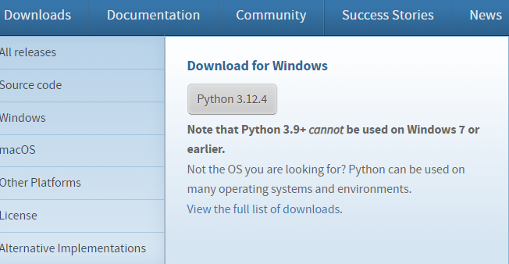

Save installer

When I am trying to instal it goes immediately to updating because I have already installed it during lectures. I hope you will not fail me. Moving on to the next setup now. Asante sana.

**MySQL**

Click download

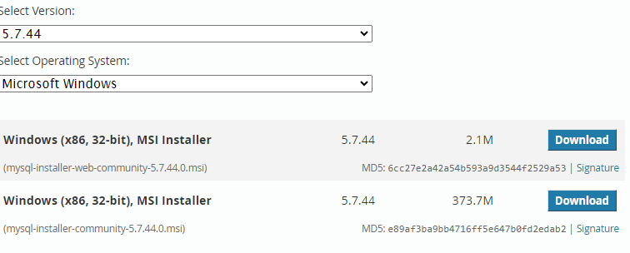

Click no thanks just start my download

Download and open installer

You know what my brother, same issue as Python please. Just don’t fail me because you can see that I tried okay. Thank you. What is important is that I managed to download everything during classes. Ngiyabonga. Ke ya leboga. Nakhensa.